Implement Programs For Time Series Data Cleaning, Loading, And Handling Time Series Data And Pre-Processing Techniques
EX:No.1 DATE:25/01/25

AIM:
Write a program to implement time series data for import library, load data, Preprocessing and visualising.
ALGORITHM:
Step 1: Install required libraries (if not already installed).
Step 2: Import necessary libraries (pandas, numpy, matplotlib).
Step 3: Load air pollution data, parse dates, and set 'date' as the index.
Step 4: Remove duplicate timestamps and fill missing values.
Step 5: Select the 'pollution_today' column.
Step 6: Remove outliers using the IQR method.
Step 7: Ensure daily data frequency.
Step 8: Resample to weekly average (optional, not used in the plot).
Step 9: Create a figure and plot daily pollution levels as a line graph.
Step 10: Set labels, title, and legend for the plot.
Step 11: Show the plot.
CODE:
import numpy as np
import pandas as pd
import seaborn as sns
import matplotlib.pyplot as plt
df = pd.read_csv(r"C:\Users\HARISH\Downloads\archive\accident.csv", header=0, index_col=0, parse_dates=True)
df.dropna(inplace=True)
Temp = df.copy()
columns_to_drop = [
'LandAverageTemperatureUncertainty', 'LandMaxTemperature',
'LandMaxTemperatureUncertainty', 'LandMinTemperature',

'LandMinTemperatureUncertainty', 'LandAndOceanAverageTemperature',
'LandAndOceanAverageTemperatureUncertainty']
Temp.drop(columns=[col for col in columns_to_drop if col in Temp.columns], inplace=True)
if Temp.shape[1] == 1:
Temp.columns = ['Temp']
Temp.index.name = "Date"
print("Remaining columns after drop:", Temp.columns)
print(Temp.head())
data = {
'Date': pd.date_range(start='2024-01-01', periods=10, freq='D'),
'Survival_Rate': [80, 85, 83, 82, 86, 88, 87, 85, 84, 83]
}
df = pd.DataFrame(data).set_index('Date')
survival_col = next((col for col in df.columns if 'survival' in col.lower()), None)
if not survival_col:
raise KeyError("No column related to 'Survival' found. Available columns:", df.columns)
print(f"Using column: {survival_col}")
plt.figure(figsize=(12, 6))
sns.lineplot(x=df.index, y=df[survival_col], marker="o", color="b")
plt.title('Road Accident Survival Rate Over Time')
plt.xlabel('Date')
plt.ylabel('Survival Rate (%)')
plt.xticks(rotation=45)
plt.grid(True)
plt.show()

OUTPUT:

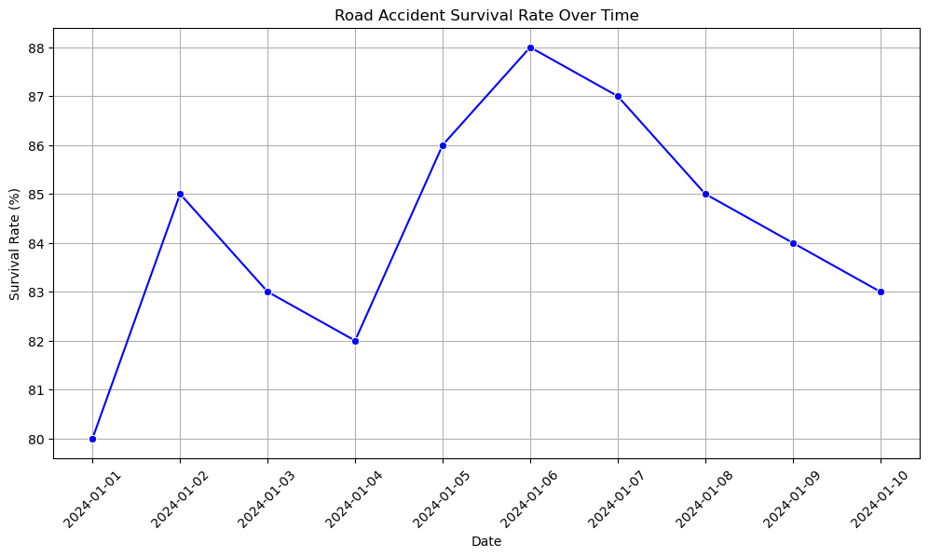

RESULT:
Thus, the program using the time series data implementation has been done successfully.

